SIMATS ENGINEERING
ASSESSMENT TOOL 3

COURSE NAME: CSA07 COURSE CODE: Computer Networks

COURSE OUTCOME COVERED
CO1: Apply the functions of OSI layer in enabling reliable data transmission across
networks. (BL2, BL3)
Assessment Tool Weightage: 30%

Annexure A
TECHNICAL PRESENTATION

Code of Conduct:
I K.Jeevan Sai Kumar Reddy (192472080) (Name / Reg No) certify that this submission is my original work and that I have adhered to the guidelines specified for this assessment. I understand that any violation of academic integrity rules will result in disciplinary action.

Signature of the student:

Annexure A

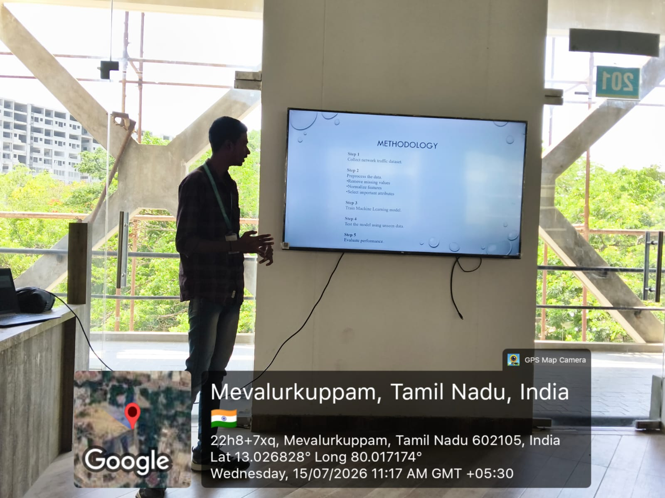
TECHNICAL PRESENTATION

Rubrics for calculation
Criteria | Weightage | Level 4 – Exemplary | Level 3 – Proficient | Level 2 – Developing | Level 1 – Beginning
Understanding of Concepts | 25 | Demonstrates thorough understanding and effectively integrates multiple  concepts/technologies | Good understanding with proper integration of most concepts | Basic understanding; limited or partial integration | Poor understanding; unable to integrate concepts
Experimental Design | 30 | Well-planned, systematic implementation with  optimal solution | Correct implementation with minor  issues | Basic implementation with errors or  inefficiencies | Incorrect or incomplete implementation
Use of Tools | 20 | Effective and advanced use of tools/technologies  with proper configuration | Appropriate use of tools with correct execution | Limited or inconsistent use of tools | Incorrect or minimal use of tools
Analysis of Results | 15 | Insightful analysis with accurate interpretation and  validation of results | Good analysis with reasonable interpretation | Basic analysis with limited insights | Poor or incorrect analysis of  results
Documentation | 10 | Clear, well-structured documentation with  diagrams, code, and results | Organized documentation  with necessary details | Basic documentation  with missing details | Poor or incomplete documentation

